**Assignment/Task**

**Summany:**

Deploy ruby application on Kubernetes cluster with complete CICD process automation.

**Note:**

* Tried to use important Devops tools for better implementation.
* All files used for this task is uploaded to **github** - **https://github.com/Harshaettigi/adjust-task**
* Docker Image is uploaded to **docker hub url**- **https://hub.docker.com/r/harshar21/adjustrepo/tags image pull - docker pull harshar21/adjustrepo:5**
* **Github** repository and **Dockerhub** repository are made **Public**.

**Prerequisite/Setup Used:**

1. Aws Account

1. Github Account

3. Docker hub account

**Tools Used:**

1. AWS Cloud (Infrastructure Hosting)

2. **Terraform** (Creating Ec2’s)

3. Github and git (Store the application code and other code.)

4. Ansible(Setup/Configure the software on Ec2)

5. **Jenkins**(CICD and Deploying the application)

6. **Docker**(Containerizing the application)

7. **Kubernetes**(Hosting the Container Application)

8. Linux and Shell Script(Server configuring)

**Aws Service Used:**

1. Iam User with programmatic access and should have Ec2 Full access permission.

2. Ec2 Instances (Ubuntu) - 4

3. Terraform installation on Ec2 - t2.micro

4. Ansible installation on Ec2 - t2.micro

5. Jenkins installation on Ec2 - t3.small

6. Minikube installation on Ec2 - t3.small

**Infrastructure Setup using Terraform:**

1. Create a Ec2(Terraform) and install install terraform (Used userdata to install terraform)
2. Used Aws Cli tool for terraform authentication with IAM user access key and secret access key
3. Create a Ec2(Ansible) with the help of terraform which is running on the terraform Ec2 - setup.tf
4. Create a Ec2(Jenkins) with the help of terraform which is running on the terraform Ec2 - setup.tf
5. Create a Ec2(Minikube) with the help of terraform which is running on the terraform Ec2 - setup.tf

---------------------------------------------------------

**Commands Used in Terraform for provisioning**

- terraform init

- terraform plan

- terraform apply

------------------------------------------------------------

**Setting up/Installing Tools/softwares on EC2 Using Ansible or Manual:**

* **Ansible** installed on Ec2 using Userdata or Manually.

--------------------------------------------------------------------

**Ansible commands and file changes**

- Add Jenkins machine host details under this file /etc/ansible/host

- run “ansible-playbook Jenkins.yaml”

---------------------------------------------------------------------

2. Install Java and Jenkins on Ec2 using Ansible playbook - jenkins.yaml

3. Install **Minikube** on Ec2 with listed commands minikube-setup.txt (Install **java** for Jenkins master and slave setup.)

**Tools Features used for deploying the application:**

* **Terraform – Provision.**
* **Ansible – Host file and playbook.**
* **Jenkins – docker plugin, pipeline job, freestyle job, master-slave.**
* **kubernetes – Deployment with 3 replicas, Nodeport for exposing on 31000 port.**

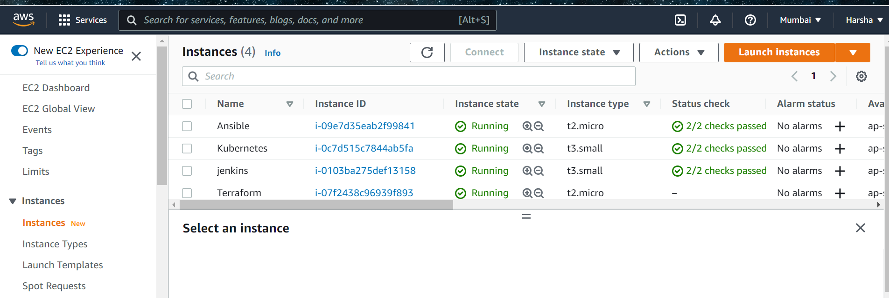

**Getting the Ruby Application.**

1. Clone the Repository https://github.com/sawasy/http_server

2. Copied http_server.rb file to Github repository - https://github.com/Harshaettigi/adjust-task

**Jenkins UI Setup:**

1. **Jenkins** is installed using **ansible** please find the **playbook** in github repository.
2. Jenkins master machine is connected to **slave machine i.e Minikube Node/Ec2**, To set the master and worker I have created a ssh connection between them and achieve that I have installed **Java** on Minikube and made **/home/ubuntu/adjust has the remote directory** to **build the jobs**.
3. On the Jenkins, plugin called docker pipeline plugin is installed to achieve build and push the docker image.
4. Added Jenkins User to **Docker group** to build the image with right permission.

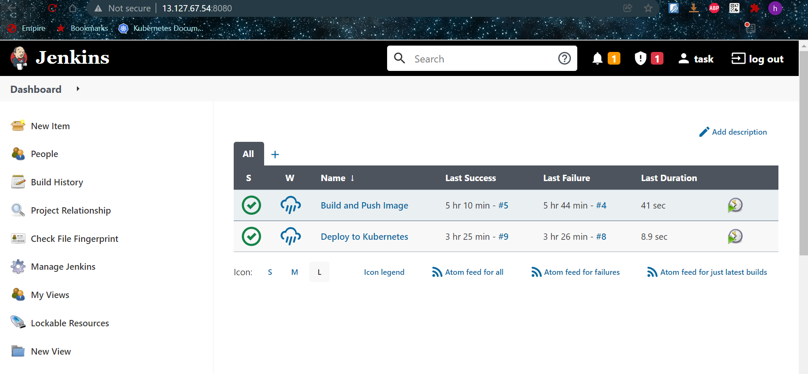

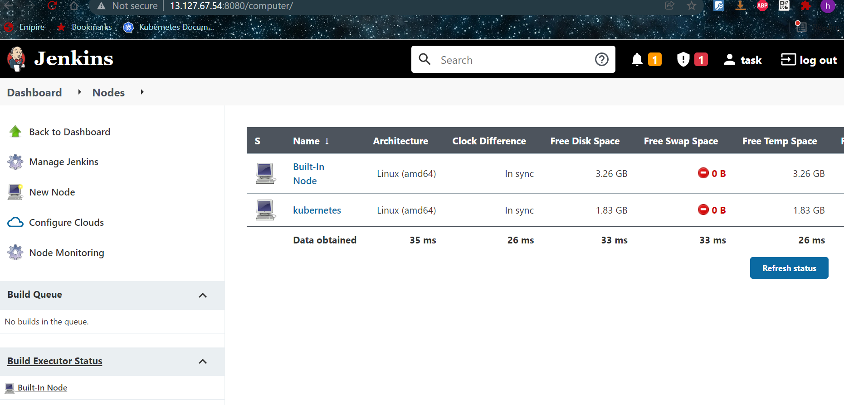

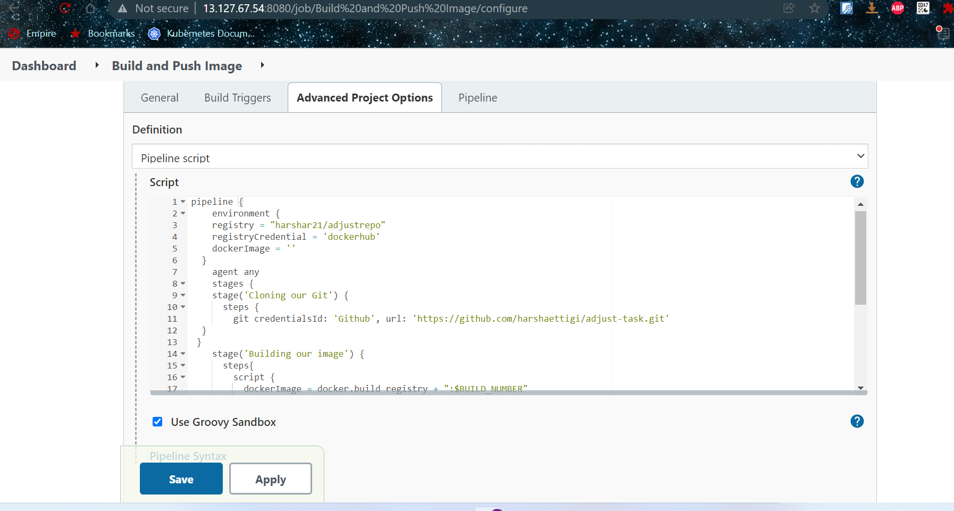

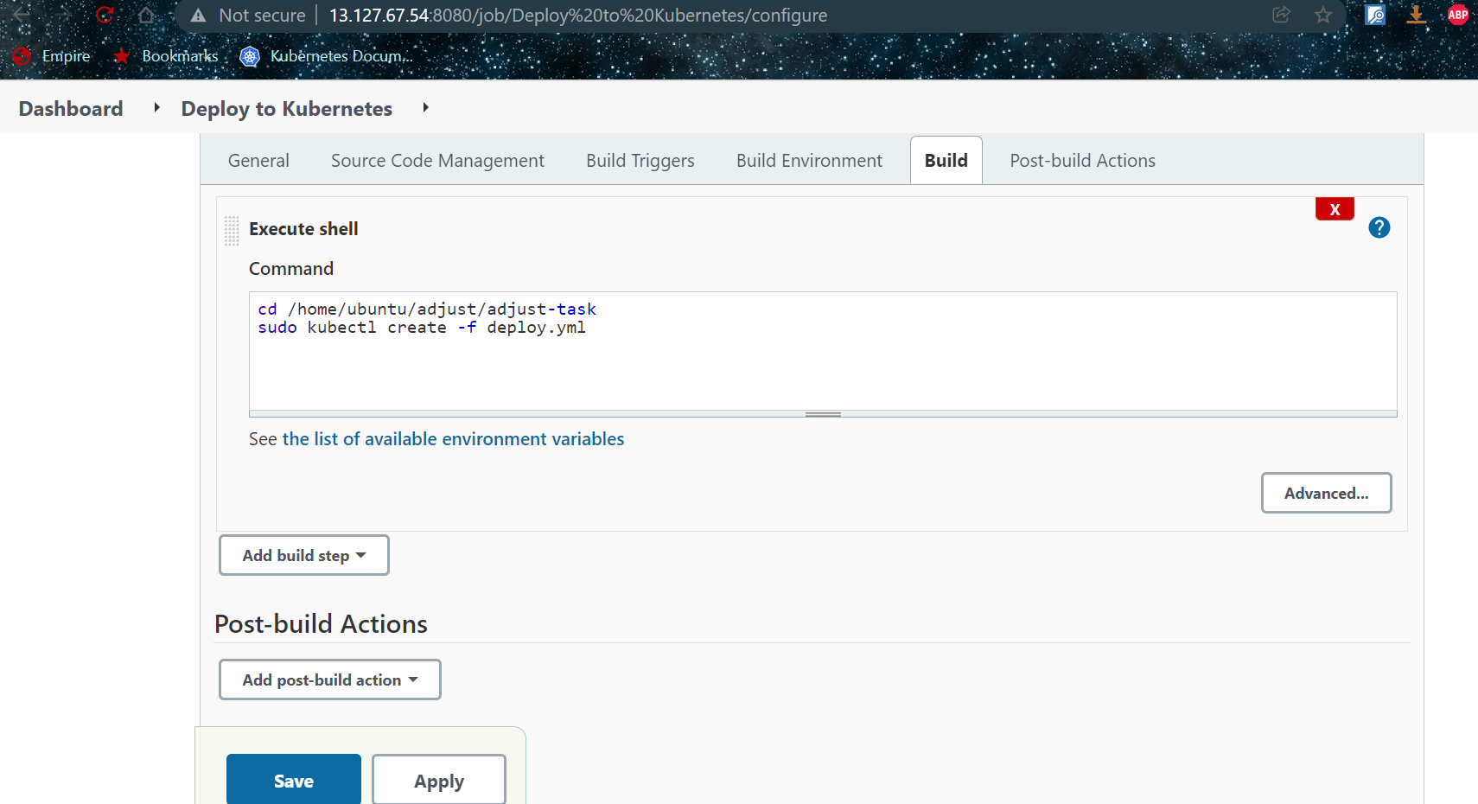

**Building and Deploying the Application:**

1. Confirm Jenkins is up and running.
2. Confirm Minikube is up and running.
3. Written a Dockerfile to build a image with ruby http_server application.
4. Create a Gemfile which is required to install bundle.
5. Write a jenkinsfile to pull the Dockerfile and build a image and push it to dockerhub account.
6. Write Kubernetes deployment script to deploy the ruby application and Nodeport script for exposing the application to the internet.
7. Created a **pipeline Jenkins job** with jenkinsfile to get the Dockerfile from github repository and build the image then push it to docker hub repository please find a file in github repo.
8. Created a **Freestyle job** to get the Kubernetes yaml files from repo and create **Deployment service and Nodeport Service.**
9. On Successful run of the both the jobs, application deployed on the Kubernetes cluster.

**Deployment Post Check**

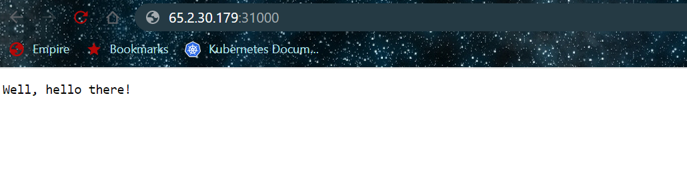



**Note:**

* **Used terraform tool its easy to use and provision the infrastructure.**
* **Used Ansible for installing Jenkins instead of manually setup.**
* **Used Jenkins for CICD, its easy to use and setup.**
* **Used Docker and Kubernetes as mentioned in the assignment.**

